1. Create s3 bucket. Give it any unique name

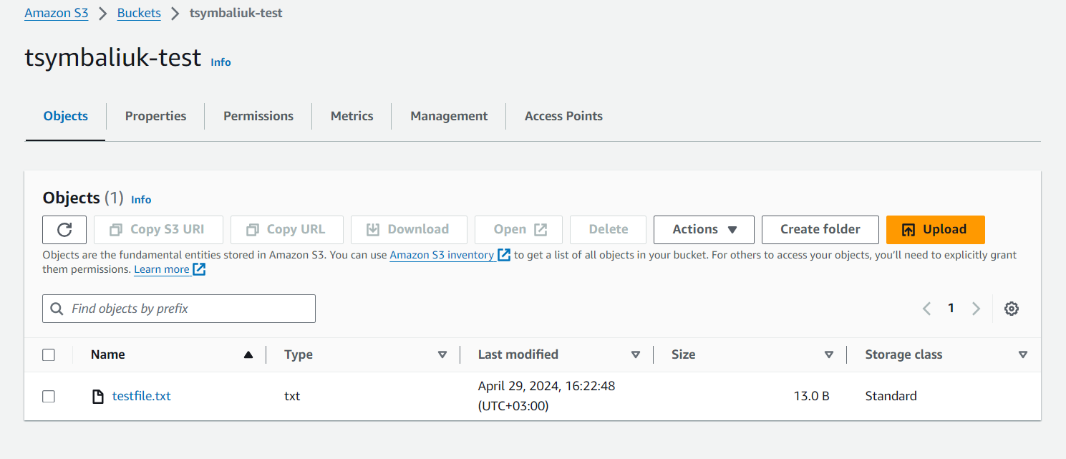

1. Upload any test file to s3. Download this file to your PC

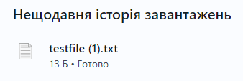

1. Create your own IAM policy which allows access to only this specific s3 bucket

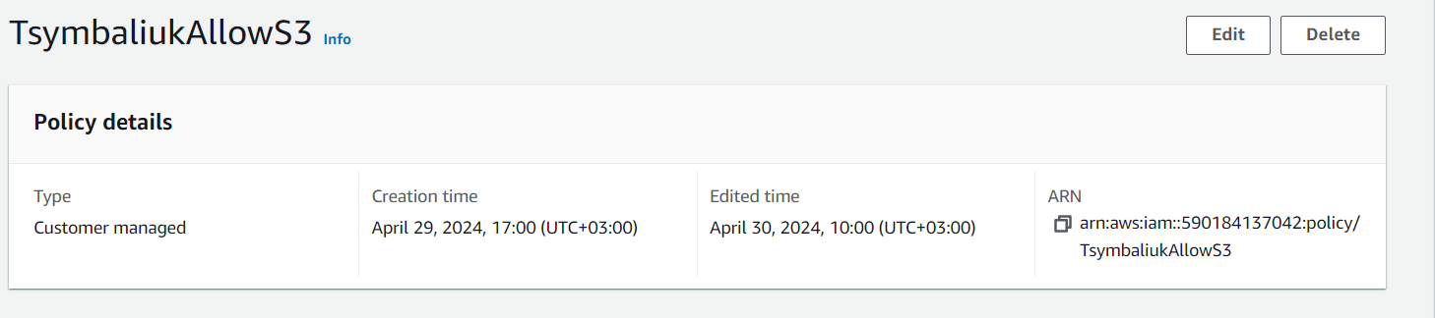

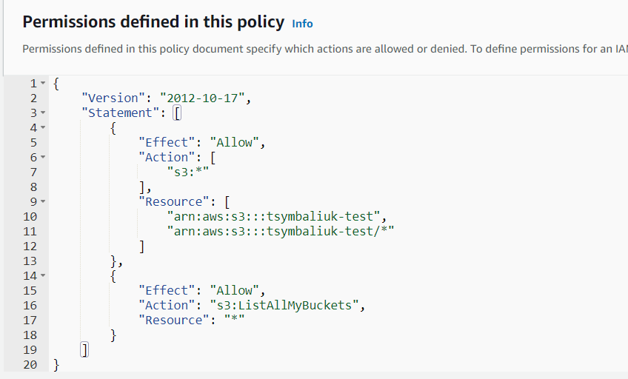

1. Create your own test user and provide him only this policy

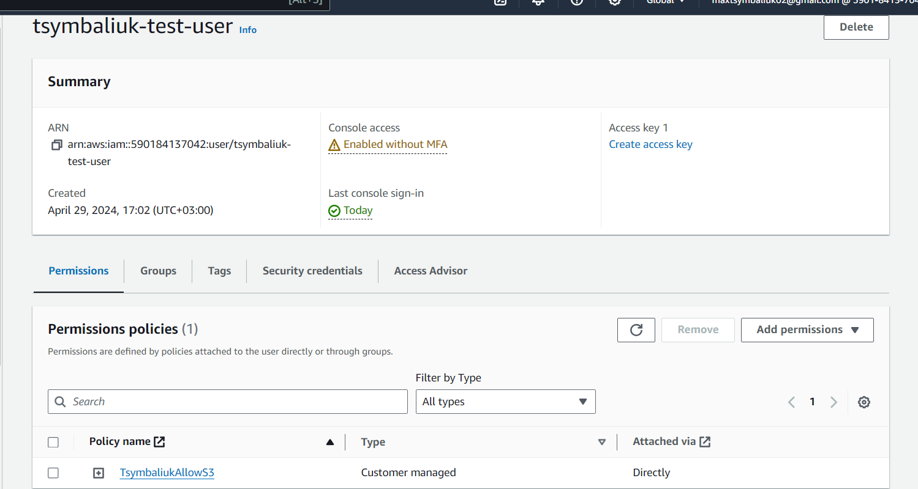

1. Login to AWS console with created user and check that this user has access only to this s3 bucket

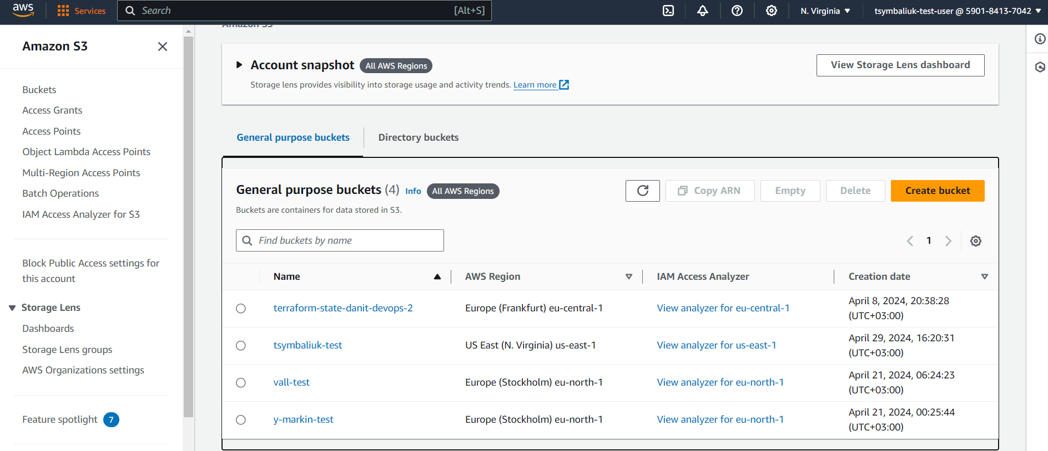

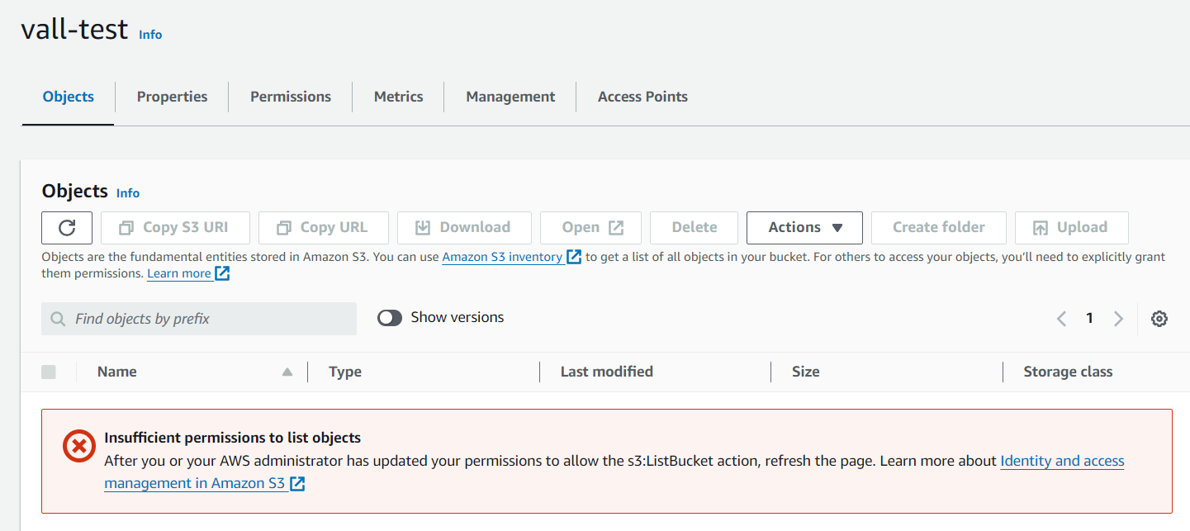

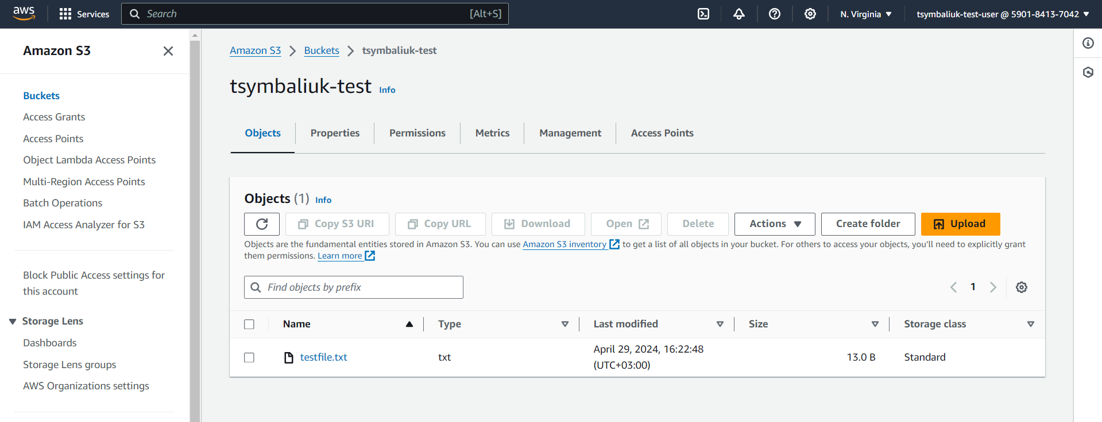

1. Remove created user, created policy, s3 bucket



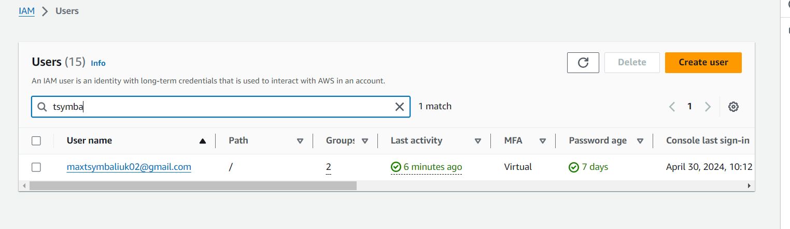

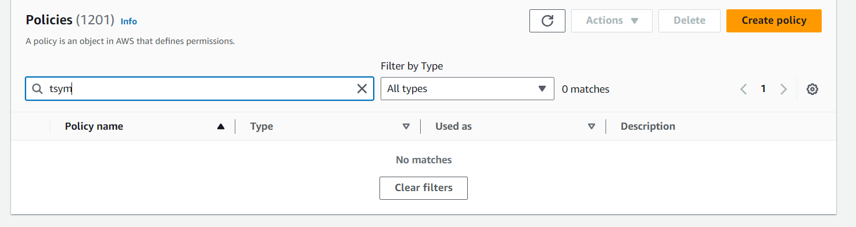

Advanced:

1. Create 2 ec2 instances with web servers

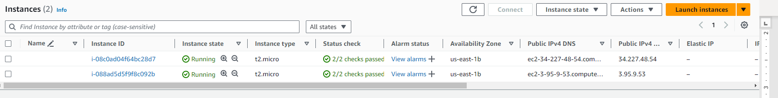

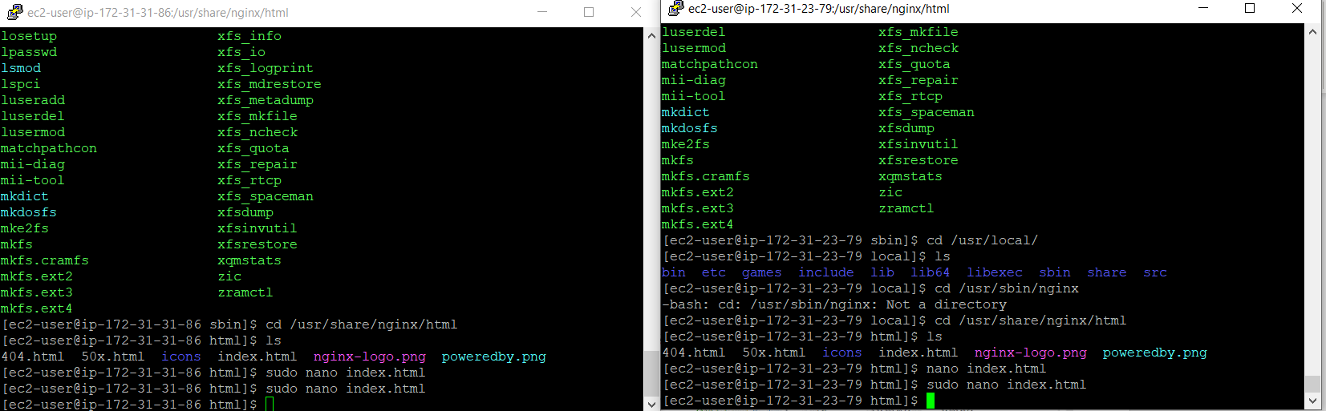

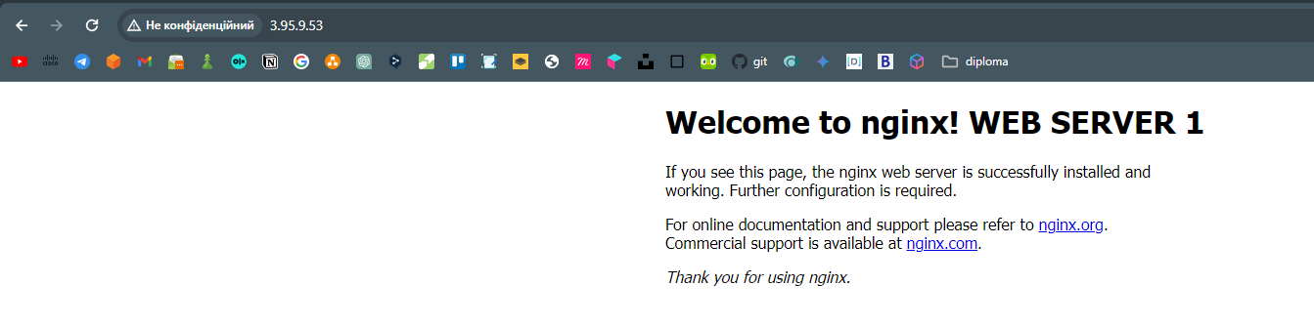

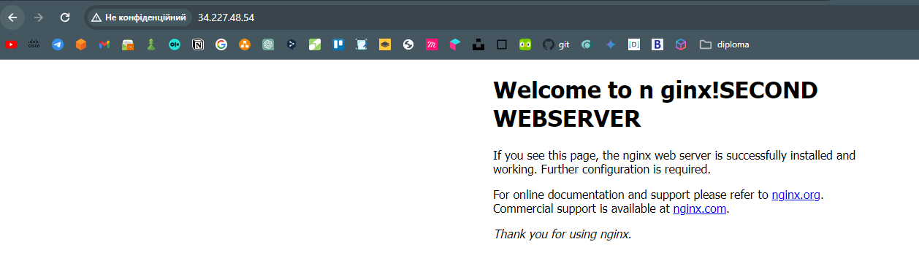

1. Put them in target group

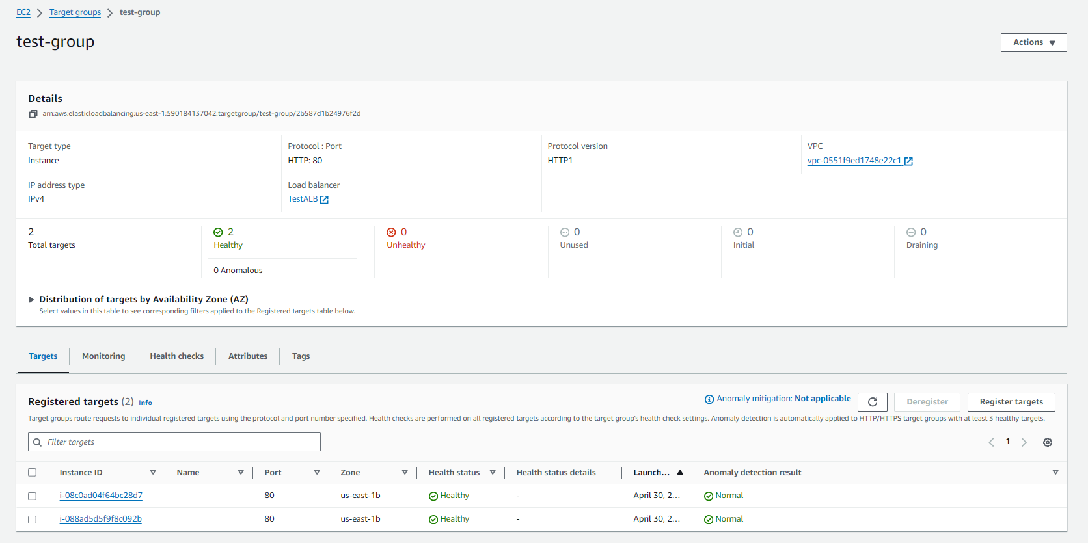

1. Create ALB and connect to target group

